**Geography 150 Lab 5: River flows, drainage basins and floods Tracy Harvey**

*Introduction*

Chapter 7 in our text is entitled “Atmospheric Disturbances” and discusses the impact of storms on the landscape. Understanding the weather patterns is a central focus, considering that water is the single most important natural agent sculpturing the earth's surface and floods are probably the most widely experienced catastrophic geologic hazards. Flood seasons may occur during melting of snows in the spring, during monsoonal rains, or during heavy precipitation events at different times of year.

The drainage basin or watershed of a river is the area that collects and directs the surface water into the river. Drainage basins of large rivers are shown in the section on rivers and streams in chapter 9 of our text (p. 251-3 or 268-70). The climate, shape, and size of the drainage are among the variables influencing the flow behavior and flood potential of a river. The height of the water is typically measured with stream gages located at strategic locations along the river valley. Many of these gages are now automated and we can look at stream flow by gage height in real time (right now).

Flood behavior of a river is based on past observations and with these observations we can make a reasonable estimate of the long term flood behavior of a river. We are using a method discussed in chapter 16 of our text (p.442-3 or 473-74).

The highest flow achieved each year by a river is recorded as the peak flow. Since the lowest flows of many rivers in the U.S. are typically during late summer and early fall, the US Geological Survey designates the water year as beginning on October 1. We can assemble as many peak flows for consecutive years as are available for a river, plot flows (volume of water in cubic feet per second) and estimate the statistical floods, e.g. The 20-year flood, the 100-year flood and so forth.

**Recurrence = (N+1)/M, where N is the number of years of observation and M is the magnitude of the peak flow.**

We can access the USGS river information with the following:

<http://waterdata.usgs.gov/nwis>

and go to "Surface water"

then "Peak flow data"

Here we may each choose a river of interest anywhere in the U.S. When selecting a station (location) we should record a group of consecutive years (I suggest 20-30 years) and record the peak flow for each year. Flow volume is reported in cfs or cubic feet per second. We then rank these flows, largest = 1 to smallest to give our M for the equation above. Finally we can plot this information, using R (recurrence) on the x axis and flow volume in cfs on the y axis, using the graph paper (provided),. We project a best fit straight line fit to our data points and extrapolate to the more infrequent (and larger) floods, e.g., the 50-year or 100-year flood.

I have included a link and example of plotting paper issued by the US Geological Survey for use in flood frequency analysis (below).

<https://geology.humboldt.edu/for_download/graphpaper/gumbel.pdf>

|  |  |  |
| --- | --- | --- |
| Rank | CFS | Recurrence |
| 1 | 2240 | 18 |
| 2 | 1840 | 9 |
| 3 | 1520 | 6 |
| 4 | 1290 | 4.5 |
| 5 | 1200 | 3.6 |
| 6 | 1200 | 3 |
| 7 | 1100 | 2.571 |
| 8 | 808 | 2.5 |
| 9 | 680 | 2 |
| 10 | 680 | 1.8 |
| 11 | 648 | 1.636 |
| 12 | 673 | 1.5 |
| 13 | 640 | 1.385 |
| 14 | 535 | 1.286 |
| 15 | 484 | 1.2 |
| 16 | 334 | 1.125 |
| 17 | 161 | 1.059 |

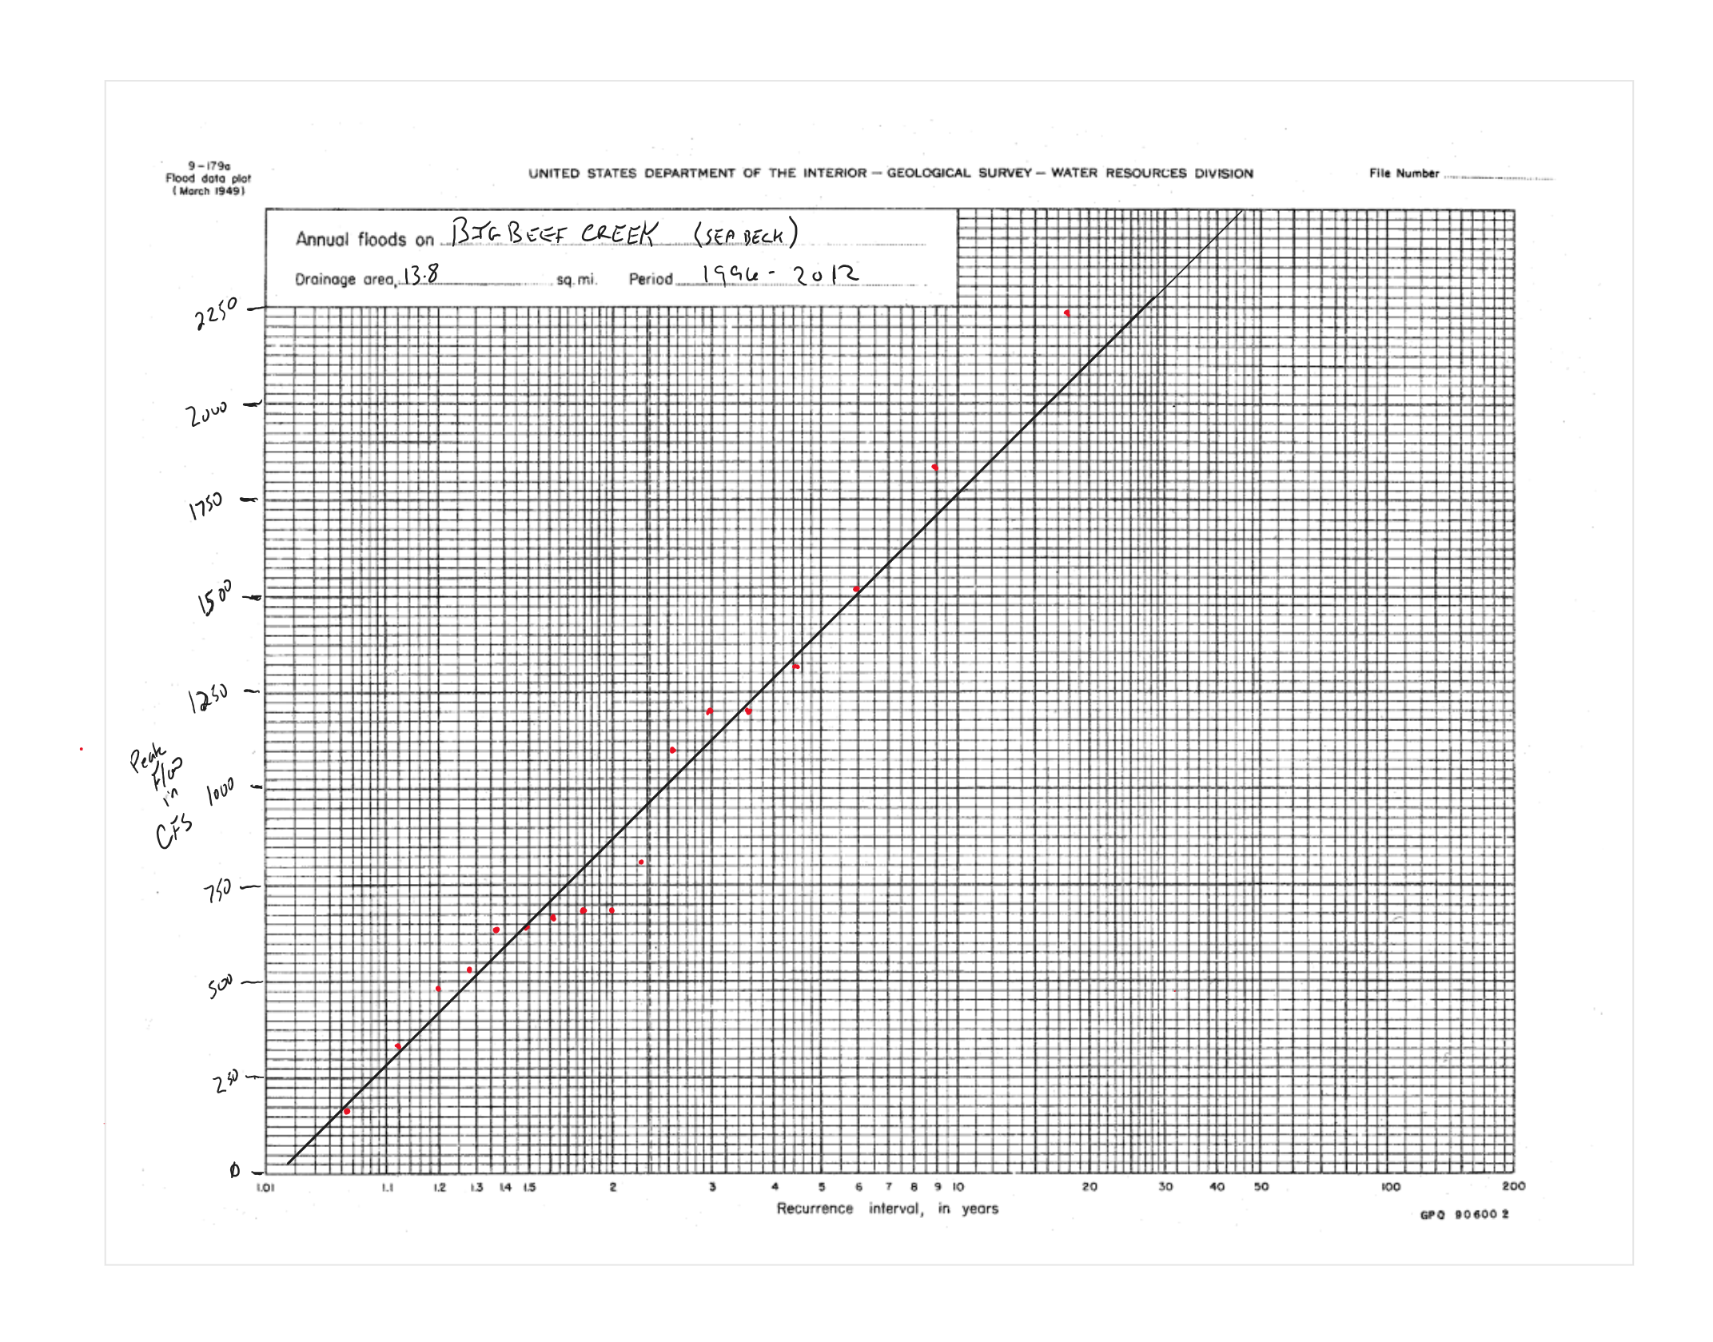

When you have completed a plot for your river, consider the following:

1. What are typical weather patterns to be expected in the region where your river is located. Are there strong seasonal patterns in this region? Does your river have high variability in its highest flows from year to year? Explain.

I chose the Big Beef Creek near Seabeck, Wa just for your reference. The seasonal patterns in the are are usually cool to cold winters with a lot of precipitation and warm to hot summers with little precipitation. So there would be a lot of water collecting during the winter months. This river does have a decently high variability in it’s highest flows from year to year it seems that every other year or two years the river will have low flow rate followed by a flow rate that is at least double of the previous year.

1. Consider the drainage basin, especially upstream from the location of the stream gage recording the data you are plotting (You might consult another map or satellite image to examine the drainage basin). What is the size of the drainage basin? What are conditions in the drainage basin, such as steepness, the presence of vegetation, urbanization, or other factors? Explain.

The Drainage area according to the data is 13.8 square miles. The conditions in the drainage basin are semi urbanized in that the drainage basin is located in a private park and the mouth of the river looks like it has a concrete spill way funneling water into the river.

1. Is your river prone to sudden flood events of large magnitude? Is your river “flashy” (showing a pattern for flash flooding) ? What is the flow predicted during a 50-year flood? A 100-year flood?

It does seem that the river is prone to sudden large magnitude flooding events. It doesn’t seem that it is prone to flash flooding though there is evidence that it has experienced at least 1 flash flood in the last 30 years. The flow predicted for the 50 Year would be 2550 cfs and the 100 would be around 2700 cfs it is hard to chart as the line is off the chart.